Project 1

Name: Brandon Tenorio

Course: CMSC 140

Date: 02-06-2020

Instructor: Dr. Wu

**Test Plan**

Test your program with at least two more test cases. Use the given data as an example. Record your data for input and output in the following table. **Make sure your tests cover all the possible scenarios.**

|  |  |  |  |  |  |
| --- | --- | --- | --- | --- | --- |
| **Test Case #** | **Input** | **Actual Input** | **Expected Output** | **Actual Output** | **Did the test pass?** |
| 1 | 2  4  5 | 2  4  5 | 24  720  17280  1036800  62208000  14  10  9  0  .8 | 24  730  17520  1051200  63072000  14  10  9  0  0.8 | Yes |
| 2 | **11**  **23**  **7** | 11  23  7 | 132  4015  96360  5781600  346896000  77  55  30  3  3.3 | 132  4015  96360  5781600  346896000  77  55  30  3  3.3 | Yes |
| 3 | 69  420  42069 | 69  420  42069 | 828  25185  604440  36266400  2175984000  4289  483  345  0  0.0 | 828  25185  604440  36266400  2175984000  4289  0  0.0 | Yes |
| 4 | 3  6  4 | 3  6  4 | 36  1095  26280  1576800  94608000  21  15  10  1  1.5 | 36  1095  26280  1576800  94608000  21  15  10  1  1.5 | Yes |

***Test 1:***

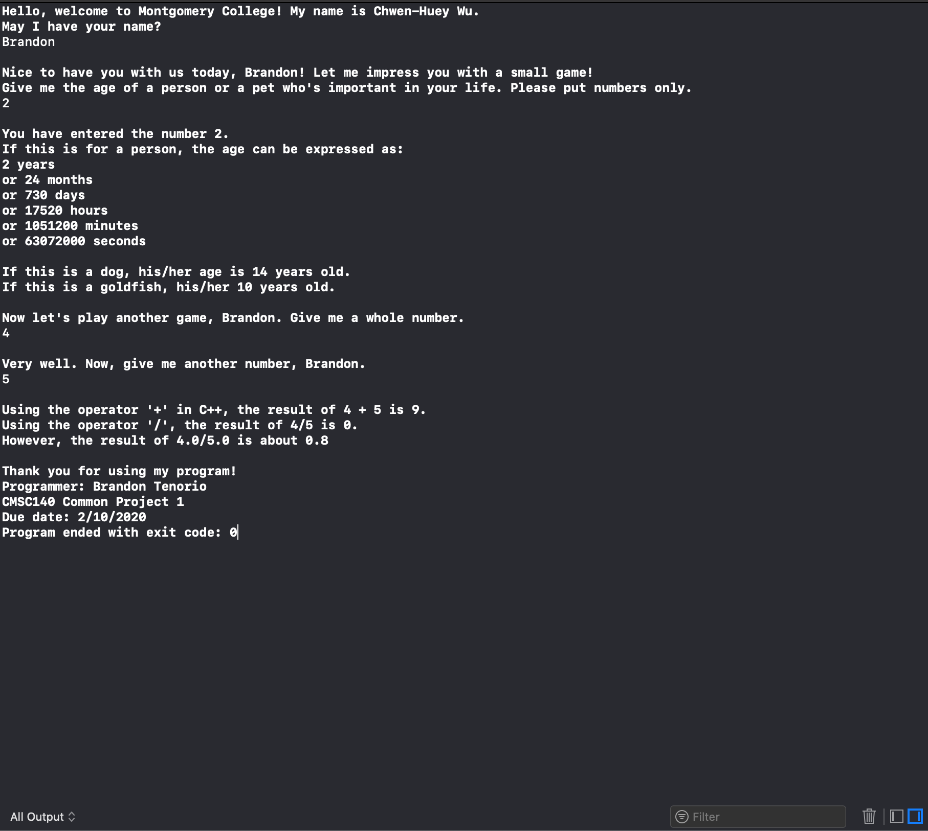

***Test 2*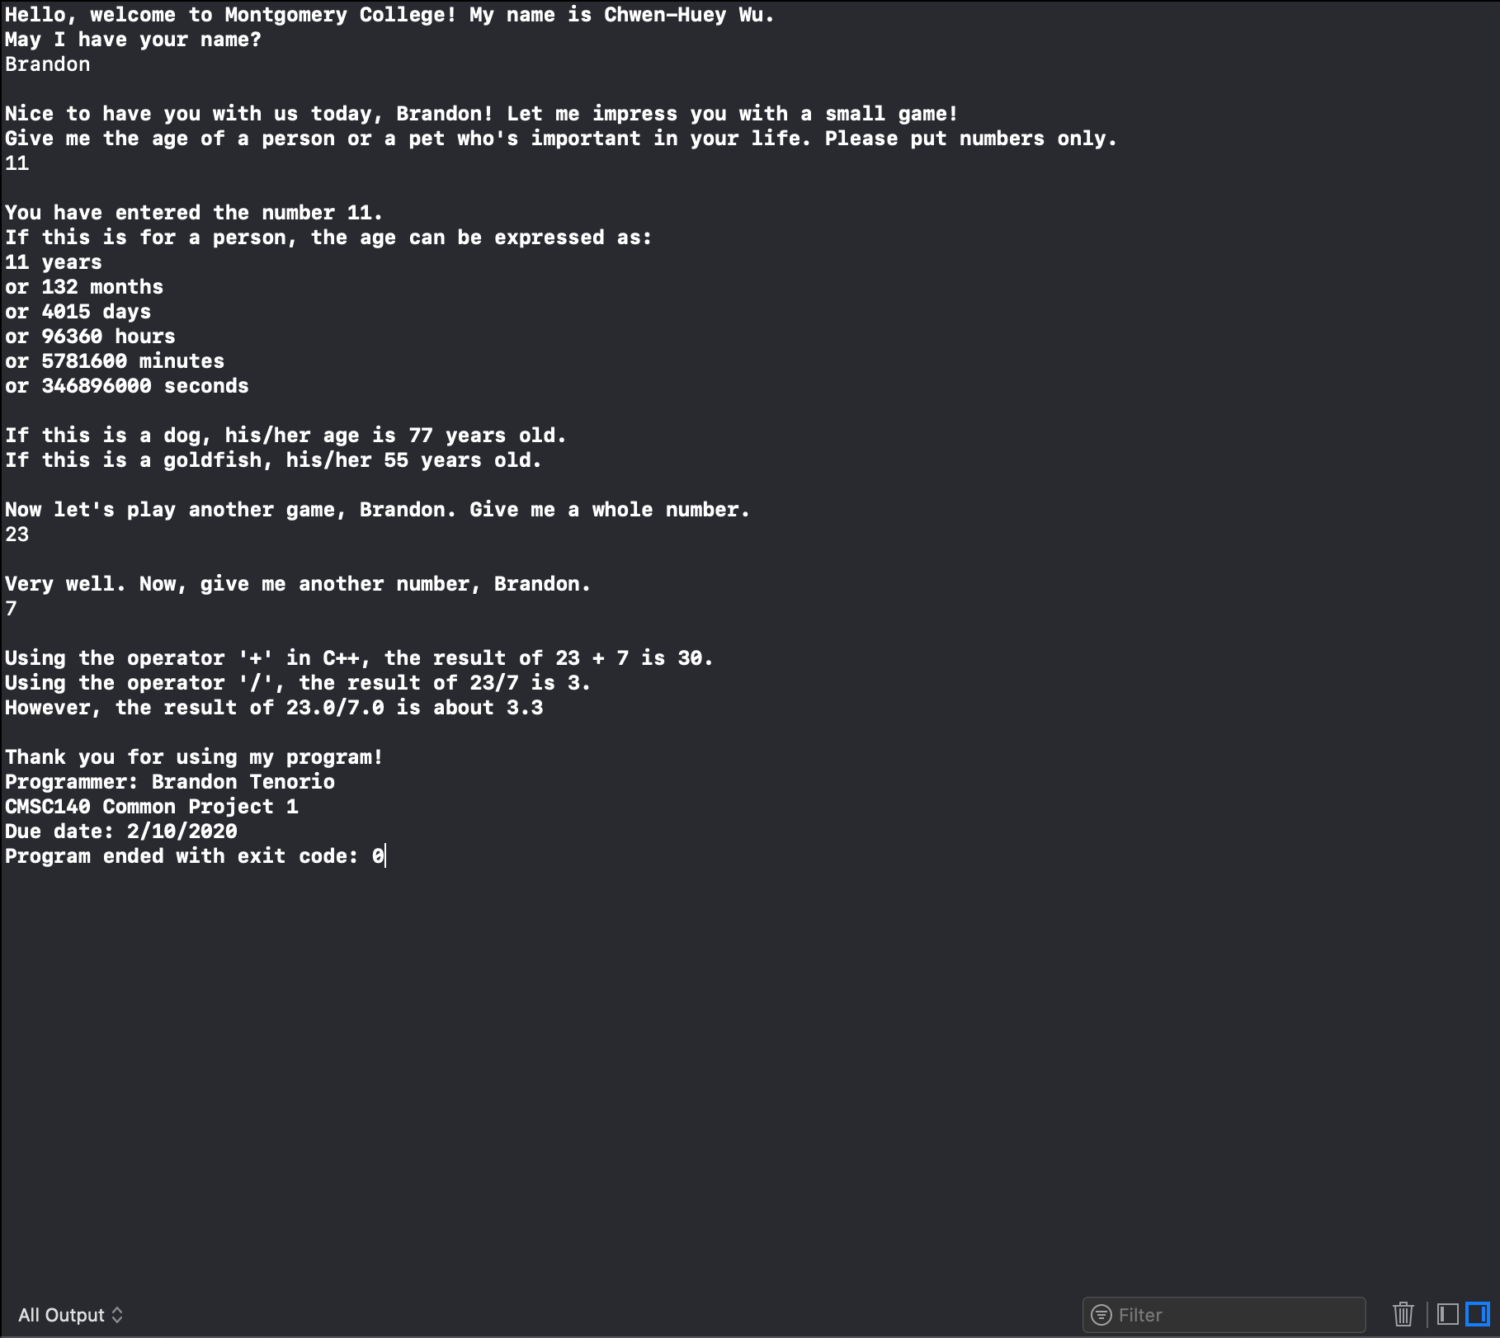**

***Test 3:***

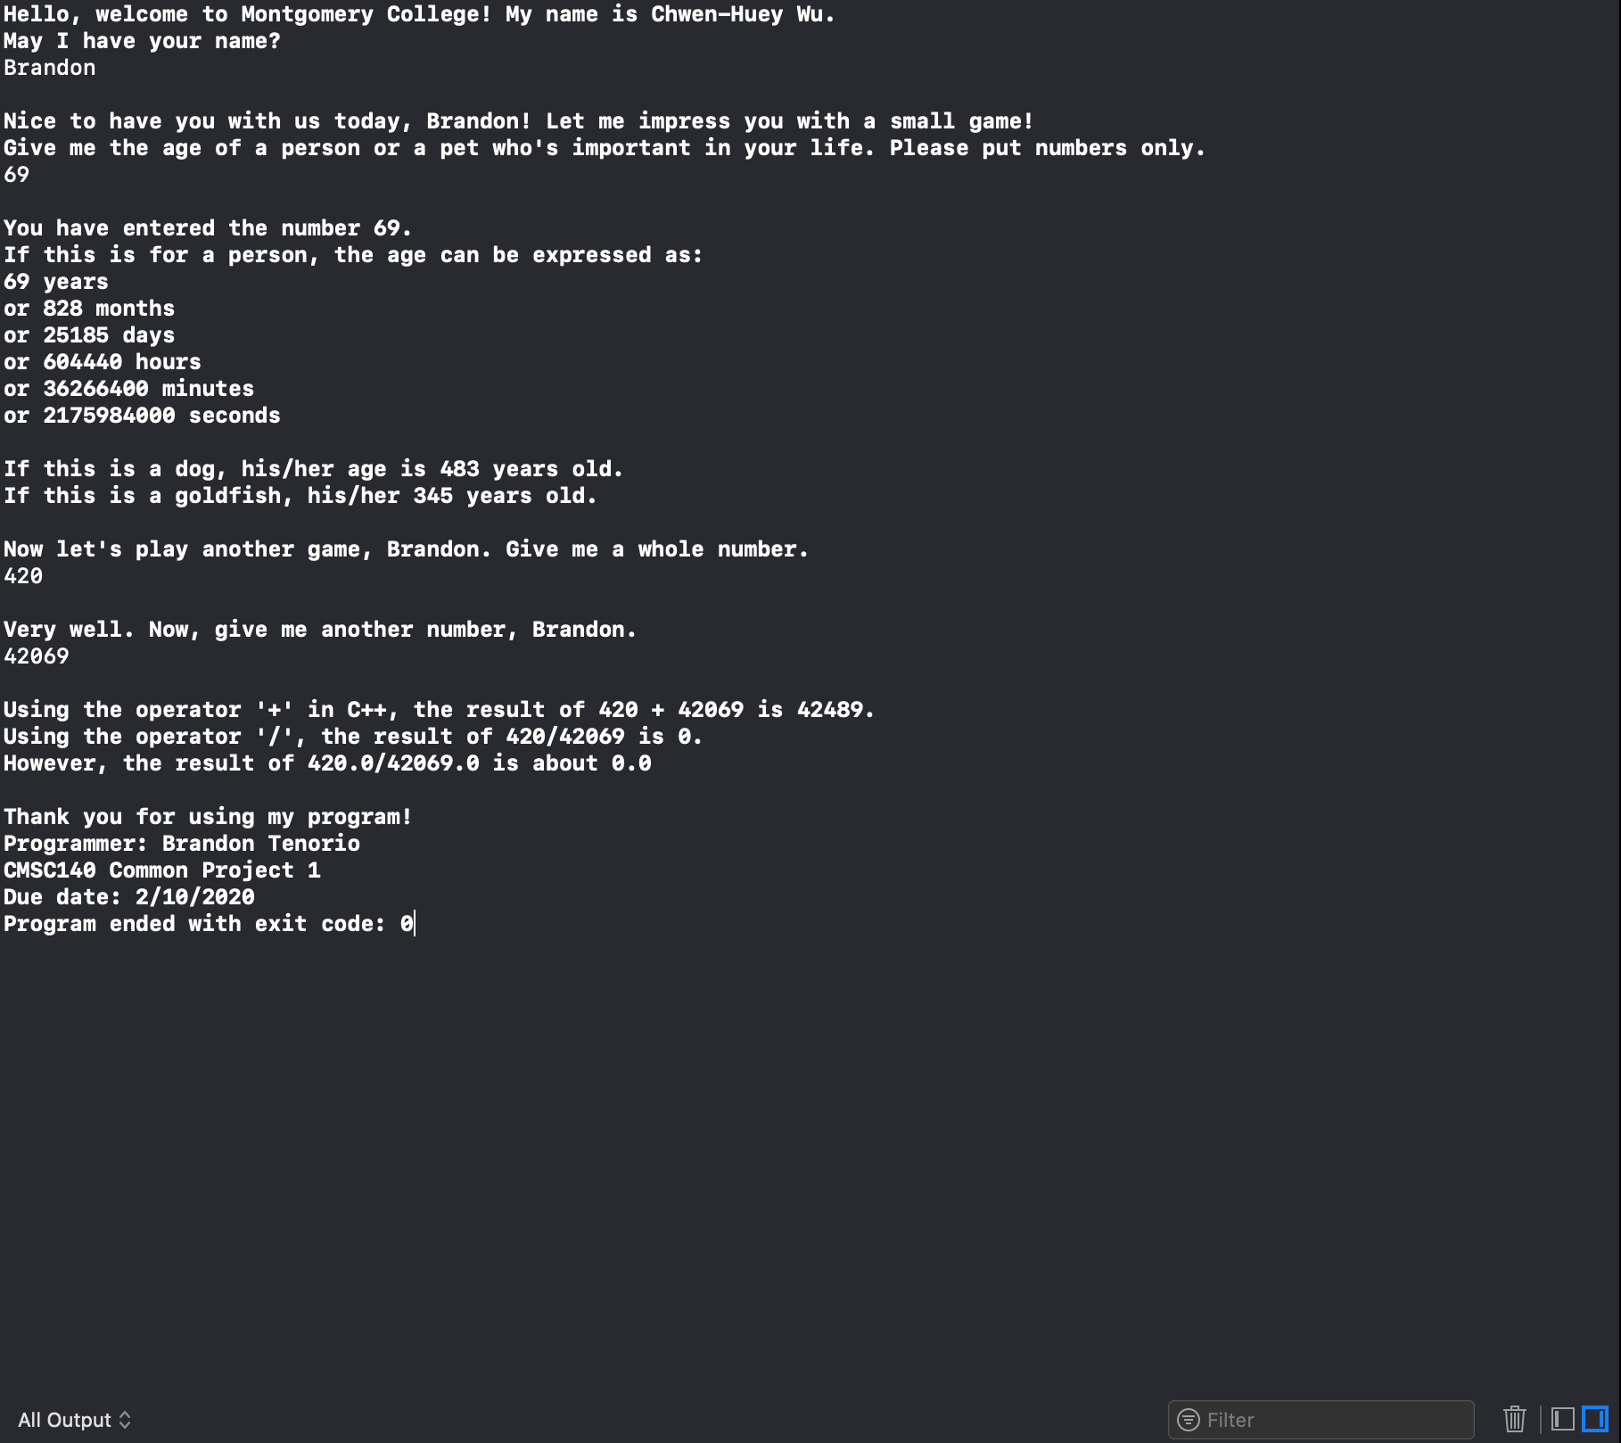

***Test 4:***

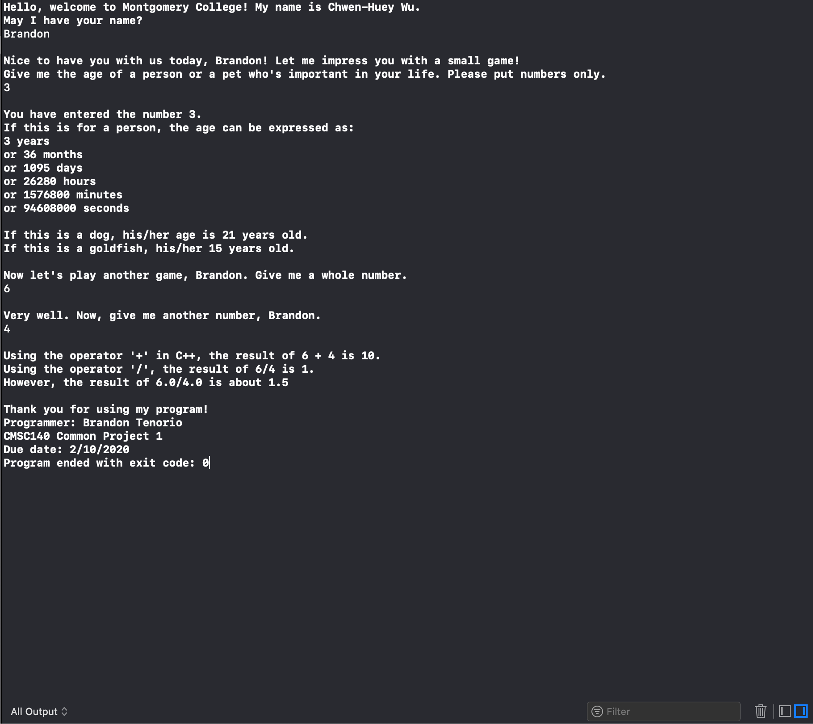

***Lesson learned:***

The main issue I had had to do with the very last line regarding mathematical operations. I couldn’t find a way to convert the user’s integer inputs into double floating points, thus I read the book again and found out about type-casting and used that to convert int to float.